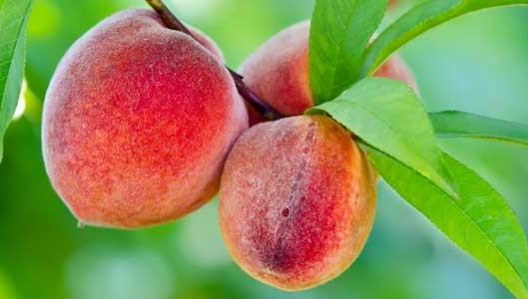
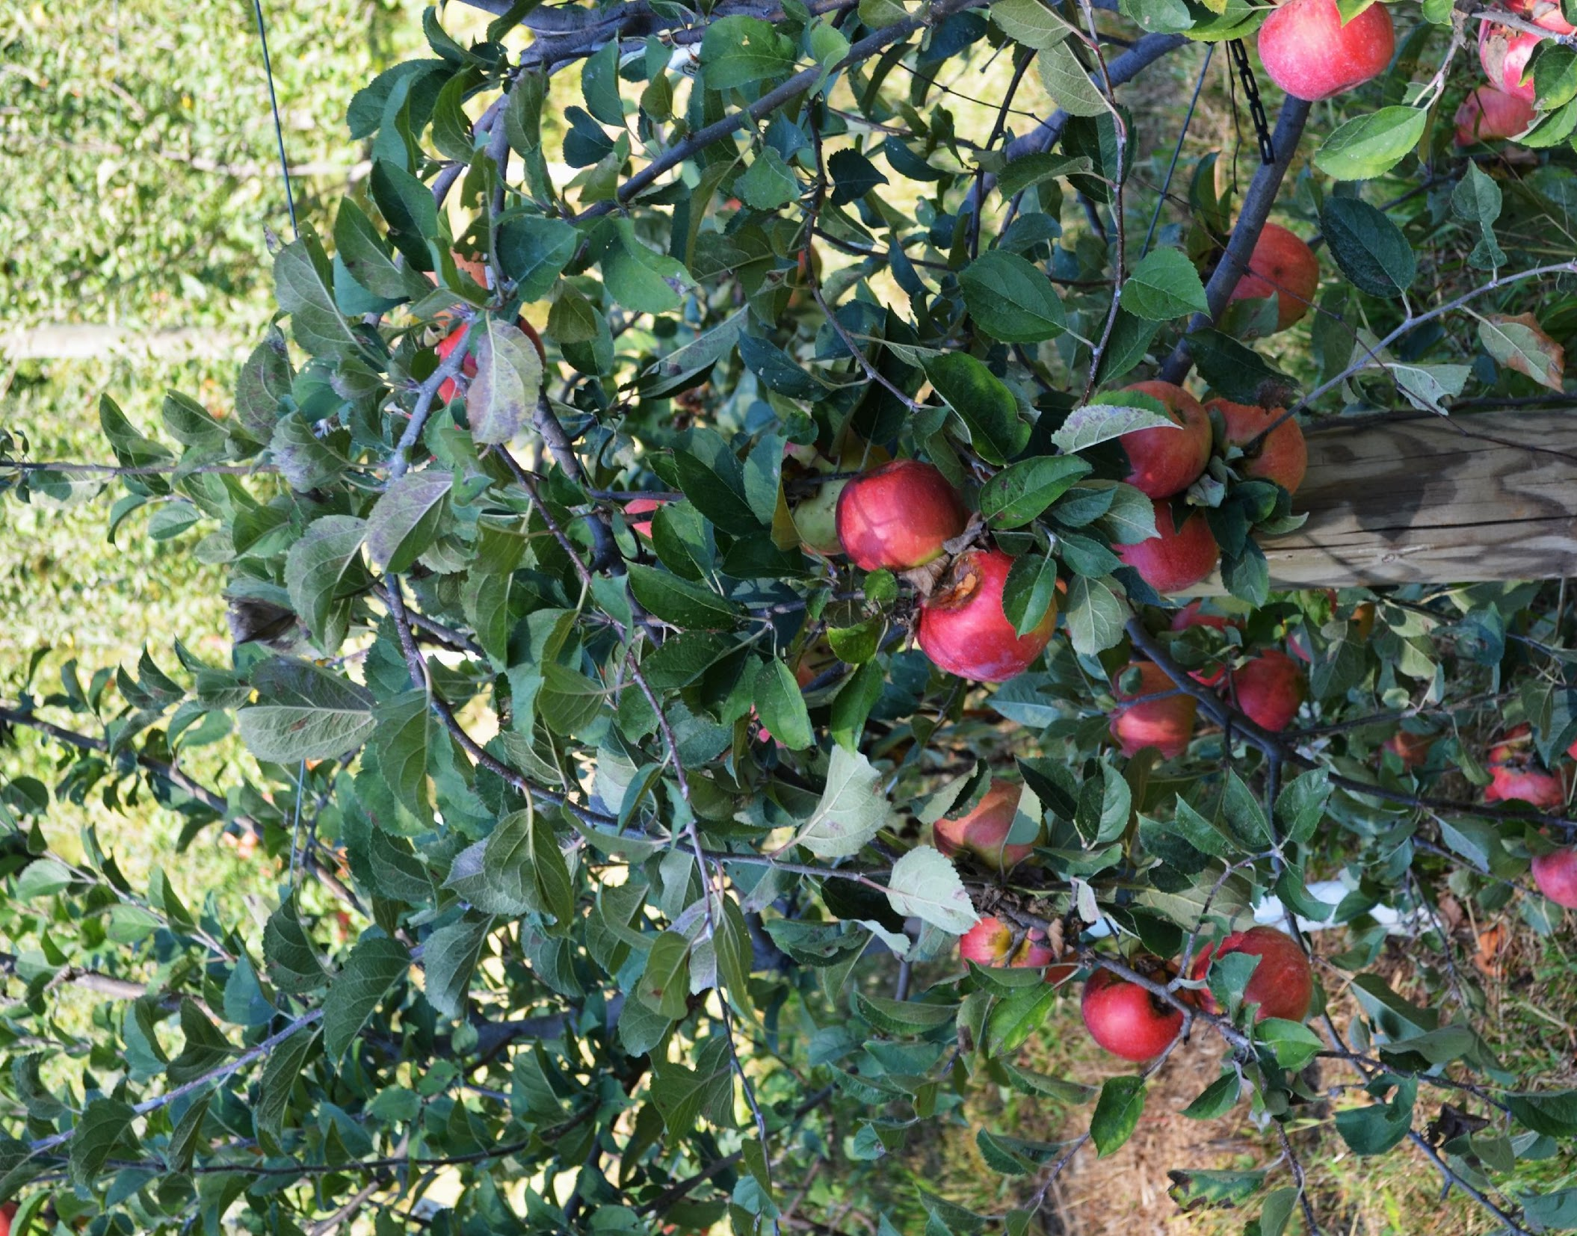
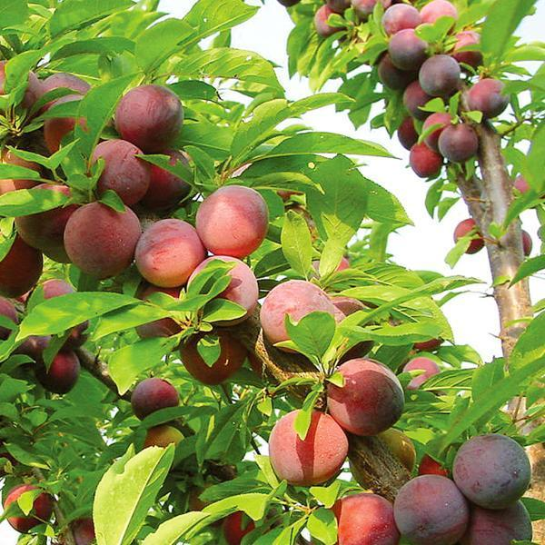

INDIAN ORCHARDS
27 Copes Lane, Media, PA 19063
610-888-6969 - indian.orchards.farm@gmail.com
Location: 2 mi. south of Rte. 1, off Rte. 352
OFFICE Phone 610-888-6969
FARM PHONE 610-564-0794

FRUIT PLUS +SHARES AVAILABLE FOR 2017

Indian Orchards is a small family-run orchard located just 30 minutes west of Philadelphia. This farm has been our home for over a century, and in that time we have been serving high quality home-grown fruits and vegetables to our neighbors and friends. We grow a wide variety of fruits, including local heritage apples picked from our 100-year-old trees, peaches and plums famous for their rich flavor and juiciness, and lush fields of blueberry and raspberry bushes grown using organic methods without the use of pesticides.
This year we are opening our farm to the wider public for the first time since our founding in 1913, and we have a limited number of Fruit Plus +Shares available. You will receive a bag filled with our finest offerings each week, supplemented from time to time with locally made preserves. Full Shares are picked up weekly at our farm, Half Shares every other week, from June through October.

While nature prevents us from being able to guarantee the availability of certain items every season, you can generally expect to find the following fruits in your share:

Blueberries - Raspberries - Blackberries - Peaches - Plums
Nectarines - Pears - Apples - Grapes - Apricots
Persimmons - - Jams - Jellies - Preserves - Fresh Veggies -
Fresh -pressed Apple Cider (unpasteurized)

Pricing: $600 for a Full Share (20 weeks), or $395 for a Half Share (10 weeks).
Page 1 of 2

Email: indian.orchards.farm@gmail.com or gailelabar@gmail.com
FRUIT SHARE PICKUP: Friday (10 AM to 5 PM) _______
Indian Orchards: Saturday (10 AM to 5 PM ________Red Hill Farm: Friday _________
ARE YOU INTERESTED IN VOLUNTEERING TO SUPPORT SUSTAINABLE AGRICULTURE ?___ yes _____no _____ OR DO YOU KNOW ANYONE WHO WOULD LIKE TO HELP FARM ?__________

NAME: ___________________________________________________________________________

ADDRESS: _____________________________________________________________________________

PHONE: ____________________________________________Email _______________________________________
SHARE SIZE: FULL ($600) _______________ HALF ($395) _______________

FULL SHARE price is $600, full shares are picked up weekly.
HALF SHARE price is $395, and is picked up every other week.

If paying by check, please make payable to Indian Orchards Farm :
Amount Paid ______________ chk# ________________ date ____________

If paying by credit card, please fill out the following:
**Cardholder name: ____________________________________

Credit Card number (Visa, Master Card):____________________
___________________________________________________

CSV (3-digit number on back of card):___________Expiration Date : _____________________

Cardholder Signature: _________________________________Date___________
** There is a 3% processing fee for payments made by credit card **
SIGNATURE: _______________________________________________ DATE: ___________

*By signing above I agree to the terms of the Fruit & Farm Share contract, and understand that as a member I will share in the bounty as well as the risks that accompany farming, and that the farm grows and harvests with my share in mind. I understand that this is a season-long commitment, and that if I am unable to pick up shares, I must inform the farm that another individual will pick it up instead that week , or forfeit the share for that week without refund. While Indian Orchards cannot guarantee any crops, it will place immediate priority on filling my share with the highest quality fruits in season.
If paying by credit card, I authorize the withdrawal of funds from my credit card account and agree to the terms of your credit card user agreement.

Please submit the completed form ASAP to assure your share.
2 OF 2

